Bridge Customer Information from Accu-Auto Rater to InsurancePro:
To bridge data from Accu-Auto, first you need to setup/install the bridge files from InsurancePro. To do so:
- Click on "Load data from Rater" from the Main Menu.
- Then click on "Accu-Auto Bridge Settings".
- Click on "Change" button to specify the location where Accu-Auto is installed on your system.
- Then click on "Install Accu-Auto Bridge" to copy over the files necessary to bridge.
- InsurancePro will give you a message saying if the bridge files were installed successfully or not.
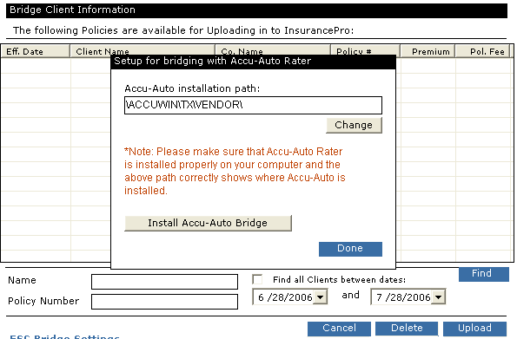
After the bridge is successfully installed,
- You should see the icon for InsurancePro on the "Breakdown" screen in Accu-Auto.
- To transfer data to InsurancePro, click on the Icon. Wait for a few moments, and you should see a message saying data transferred, and InsurancePro would ask if you would like to transfer the data.
- If you choose "Yes", InsurancePro will automatically add the bridged customer to InsurancePro, and take you to the policy Summary Screen in InsurancePro.
- If you choose "No", InsurancePro will add the client in the batch area to be processed later.
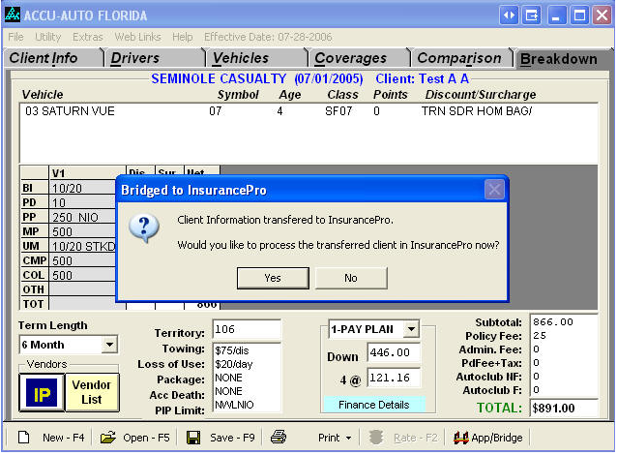
Transferring Clients into InsurancePro
All the clients that you have bridged from another rating system to InsurancePro will be listed here. Select the ones that you want to upload into InsurancePro, and click on “Upload”. Also note that from this screen, you can delete unwanted clients, and also search for the person if the list is too large. If there are clients in the list that you do not want to transfer, you can click on "Delete" to remove them from the list.
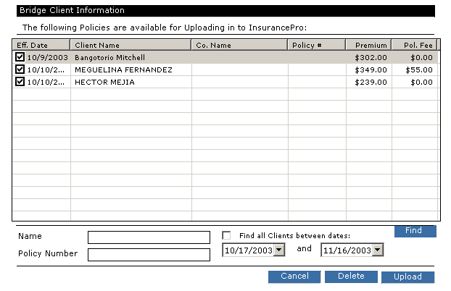
After clicking on the "Upload" button, InsurancePro will display a list of options that you can specify for the client being uploaded. Some info might have bridged over, and some may not be there. You can just double check and fill in as much as you want. You can also change the policy status from Active to Quote from this option
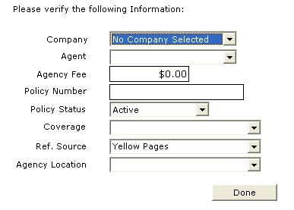
Once you have transferred information about a client to InsurancePro, you can go the "Find Client" screen to look up and process the policy.
Note: If you choose to pull up a client over to InsurancePro right after bridging by selecting "Yes" to the option for processing a client into InsurancePro, and process the client as an Active Policy in InsurancePro, you must receive a payment for the policy also. If you don't receive a payment after bridging, InsurancePro will automatically change the status to a Quote. This applies only to TurboRater and Accu-Auto products.
